Fishy Business: Managing Wildlife in Ontario

Grade Level: 9
Subject Area: Science
Time Required: 1-2 classes or 90 minutes

In this Lesson Kit:

Lesson Overview 2
Specific Expectations 2
Materials/Resources 3
Lesson/Activity 3
Background/Preparation 3
Activation 3
Activity 3
Summative 4
Assessment 5
Appendix I: Information about the Sea Lamprey 7
Background Information 8
Appendix II: Lesson Worksheets and Resources 10
Rise of the Sea Lamprey Handout………………………………………………………...11
Gathering/Organizing Evidence Worksheet 12
Primary Source 1 13
Primary Source 2 14
Primary Source 3 15
Primary Source 4 16
Primary Source 5 17

Lesson Overview

Summary: using primary source evidence, students will assess the impact of humans on the sustainability of different ecosystems through a case study of the response to rising populations of sea lampreys in the Great Lakes.

Key Question: what were the outcomes of Ontario’s sea lamprey control program?

Big Ideas:

- Ecosystems are dynamic and have the ability to respond to change, within limits, while maintaining their ecological balance.
- Humans have the responsibility to regulate their impact on the sustainability of ecosystems in order to preserve them for future generations.
- Scientific investigation skills

Critical Thinking Concepts:

- Use primary source evidence
- Identify continuity and change
- Take historical perspectives

Specific Expectations

After this lesson, students will:

- A1: demonstrate scientific investigation skills (related to both inquiry and research) in the four areas of skills (initiating and planning, performing and recording, analyzing and interpreting, and communicating);
- B1: assess the impact of human activities on the sustainability of terrestrial and/or aquatic ecosystems, and evaluate the effectiveness of courses of action intended to remedy or mitigate negative impacts;
- B2: investigate factors related to human activity that affect terrestrial and aquatic ecosystems, and explain how they affect the sustainability of these ecosystems;
- B3: demonstrate an understanding of the dynamic nature of ecosystems, particularly in terms of ecological balance and the impact of human activity on the sustainability of terrestrial and aquatic ecosystems.

Materials/Resources

- Paper for printing activity sheets
- Blackboard, whiteboard, or chart paper (with writing tool)
- Handouts and worksheet provided in this lesson kit:

Lesson/Activity

Background/Preparation

- Students should be familiar with the Great Lakes water system.
- Students should be familiar with the process of scientific investigation.
- Teacher preparation: begin by reading “Background Information” in Appendix I of this lesson kit.

Activation

- Begin with a scenario for students to discuss, either as a class or in small groups:

Imagine you are a scientist working for the province of Ontario, in charge of monitoring fish populations in lakes and waterways.

If you observed that large numbers of trout in the Great Lakes were being killed by a new predator species, what would you do?

- Have students discuss their responses for 5-10 minutes, walking around to each group to listen to their ideas.
- As a class, make a list of the different plans or ideas proposed by each group.
- Hold a group discussion using the following question:

Should humans respond to changes in animal populations in their shared natural environment? Why or why not?

Activity

Summary: using primary sources, students will identify evidence which demonstrates Ontario’s approach to the sea lamprey problem. They will organize this evidence as contributing to positive, negative, or neutral outcomes for aquatic and terrestrial ecosystems. Working as a group, they will assemble a timeline of the steps taken to manage the sea lamprey population, and then discuss their conclusions.
Instructions:
- Share the “Rise of the Sea Lamprey” info sheet from Appendix II of this lesson kit with students, either displayed with a projector or provided as a handout.
  - Using the information from the sheet, walk the class through the story of the sea lamprey’s arrival in the Great Lakes.
- Divide the students into pairs or small groups.
- Pass out copies of the Primary Source handouts and Gathering/Organizing Evidence worksheet from Appendix II of this lesson kit to each pair or group.
  - Have students work together for 20-25 minutes to review the handouts provided and complete the worksheet.
- Working as a class, create a large-scale timeline (on a blackboard, whiteboard, projection, or using another long surface) which outlines Ontario’s response to the sea lamprey problem.
  - Draw a horizontal line across the surface being used to create your timeline, with the year 1954 at the left end as your starting point.
  - Ask students to name each step, in succession, taken by the governments of Ontario, Canada, and the United States to address the sea lamprey problem.
  - With each step, have students identify the year the step started; write this on the timeline next to the step.
  - With each step, ask students to name the Primary Source handout which illustrates, demonstrates, or describes the action taken.
  - As each group shares their observations from their analysis of the primary source, check in with the class to track their understanding of the purpose, tone, and perspectives apparent in each archival record.

Summative

Finally, bring the discussion back to the initial activating question – should humans respond to changes in animal populations in their shared natural environment?
Ask students: given the evidence you’ve seen regarding the sea lamprey control program, why is human intervention in a shared natural environment so complicated? What does successful intervention look like?

Assessment
Categories | Level 1 | Level 2 | Level 3 | Level 4
Knowledge and Understanding: subject-specific content acquired in each course (knowledge), and the comprehension of its meaning and significance (understanding)
 | The student:
Knowledge of content  (ie: facts, terms, definitions) | -demonstrates limited knowledge of content | -demonstrates some knowledge of content | -demonstrates considerable knowledge of content | -demonstrates thorough knowledge of content
Understanding of content  (ie: concepts, ideas, theories, and/or technologies) | -demonstrates limited understanding of content | -demonstrates some understanding of content | -demonstrates considerable understanding of content | -demonstrates thorough understanding of content
Thinking and investigation: the use of critical and creative thinking skills and inquiry, research, and problem-solving skills and/or processes
 | The student:
Use of initiating and planning skills and strategies  (ie: formulating questions, identifying the problem, developing hypotheses, selecting strategies and resources, developing plans) | -uses initiating and planning skills and strategies with limited effectiveness | -uses initiating and planning skills and strategies with some effectiveness | -uses initiating and planning skills and strategies with considerable effectiveness | -uses initiating and planning skills and strategies with a high degree of effectiveness
Use of processing skills and strategies  (ie: performing and recording, gathering evidence and data, observing, manipulating materials and using equipment safely, solving equations, proving) | -uses processing skills and strategies with limited effectiveness | -uses processing skills and strategies with some effectiveness | -uses processing skills and strategies with considerable effectiveness | -uses processing skills and strategies with a high degree of effectiveness
Use of critical/creative thinking processes and strategies  (ie: analysing, interpreting, problem solving, evaluating, forming and justifying conclusions on the basis of evidence) | -uses critical/creative thinking processes, skills, and strategies with limited effectiveness | -uses critical/creative thinking processes, skills, and strategies with some effectiveness | -uses critical/creative thinking processes, skills, and strategies with considerable effectiveness | -uses critical/creative thinking processes, skills, and strategies with a high degree of effectiveness
Communication: the conveying of meaning through various forms
 | The student:
Expression and organization of ideas and information (ie: clear expression, logical organization) in oral, visual, and written forms | -expresses and organizes ideas and information with limited effectiveness | -expresses and organizes ideas and information with some effectiveness | -expresses and organizes ideas and information with considerable effectiveness | -expresses and organizes ideas and information with a high degree of effectiveness
Communication for different audiences and purposes (ie: to inform, to persuade) in oral, visual, and written forms | -communicates for different audiences with limited effectiveness | -communicates for different audiences with some effectiveness | -communicates for different audiences with considerable effectiveness | -communicates for different audiences with a high degree of effectiveness
Use of conventions, vocabulary, and terminology of the discipline (ie: symbols, formulae, scientific notation, SI units) | -uses conventions, vocabulary, and terminology of the discipline with limited effectiveness | -uses conventions, vocabulary, and terminology of the discipline with some effectiveness | -uses conventions, vocabulary, and terminology of the discipline with considerable effectiveness | -uses conventions, vocabulary, and terminology of the discipline with a high degree of effectiveness
Application: the use of knowledge and skills to make connections within and between various contexts
 | The student:
Application of knowledge and skills  (ie: concepts and processes, scientific investigation skills) in familiar contexts | -applies knowledge and skills in familiar contexts with limited effectiveness | -applies knowledge and skills in familiar contexts with some effectiveness | -applies knowledge and skills in familiar contexts with considerable effectiveness | -applies knowledge and skills in familiar contexts with a high degree of effectiveness
Transfer of knowledge and skills  (ie: concepts and processes, scientific investigation skills) to new contexts | -transfers knowledge and skills to new contexts with limited effectiveness | -transfers knowledge and skills to new contexts with some effectiveness | -transfers knowledge and skills to new contexts with considerable effectiveness | -transfers knowledge and skills to new contexts with a high degree of effectiveness
Making connections between science, technology, society, and the environment (ie: assessing the impact of science on technology, people and other living things, and the environment) | -makes connections between science, technology, society, and the environment with limited effectiveness | -makes connections between science, technology, society, and the environment with some effectiveness | -makes connections between science, technology, society, and the environment with considerable effectiveness | -makes connections between science, technology, society, and the environment with a high degree of effectiveness

Appendix I: Information about the Sea Lamprey

Background Information

“Sea Lamprey: A Great Lakes Invader”

Source: Great Lakes Fishery Commission, www.glfc.org/sea-lamprey.php

Sea lampreys (Petromyzon marinus) are parasitic fish native to the Atlantic Ocean. Sea lampreys, which parasitize other fish by sucking their blood and other body fluids, have remained largely unchanged for more than 340 million years and have survived through at least four major extinction events.

Sea lampreys are unique from many other fishes in that they do not have jaws or other bony structures, and instead possess a skeleton made of cartilage. While sea lampreys resemble eels, they are not related and are set apart by their unique mouth: a large oral sucking disk filled with sharp, horn-shaped teeth surrounding a razor sharp rasping tongue.

How do sea lampreys kill fish?

Sea lampreys attach to fish with their suction cup mouth then dig their teeth into flesh for grip. Once securely attached, sea lampreys rasp through the fish’s scales and skin with their sharp tongue. Sea lampreys feed on the fish’s body fluids by secreting an enzyme that prevents blood from clotting, similar to how a leech feeds off its host.

In their native Atlantic Ocean, thanks to co-evolution with fish there, sea lampreys are parasites that typically do not kill their host. In the Great Lakes, where no such co-evolutionary link exists, sea lampreys act as predators, with each individual capable of killing up to 40 pounds (more than 20 kilograms) of fish over their 12-18 month feeding period.

Host fish in the Great Lakes are often unable to survive sea lamprey parasitism, either dying directly from an attack or from infections in the wound after an attack. Host fish that survive an attack often suffer from weight loss and a decline in health and condition.

Sea lampreys prey on most species of large Great Lakes fish such as lake trout, brown trout, lake sturgeon, lake whitefish, ciscoes, burbot, walleye, catfish, and Pacific salmonids including Chinook and coho salmon and rainbow trout/steelhead.

Where are sea lampreys found?

The first recorded observation of a sea lamprey in the Great Lakes was in 1835 in Lake Ontario. Niagara Falls served as a natural barrier, confining sea lampreys to Lake Ontario and preventing them from entering the remaining four Great Lakes. However, in the late 1800s and early 1900s, improvements to the Welland Canal, which bypasses Niagara Falls and provides a shipping connection between Lakes Ontario and Erie, allowed sea lampreys access to the rest of the Great Lakes.

Within just a short time, sea lampreys spread throughout the system: into Lake Erie by 1921, Lakes Michigan and Huron by 1936 and 1937, and Lake Superior by 1938. Sea lampreys were able to thrive once they invaded the Great Lakes because of the availability of excellent spawning and larval habitat, an abundance of host fish, a lack of predators, and their high reproductive potential—a single female can produce as many as 100,000 eggs!

What is the impact of the sea lamprey invasion?

Sea lampreys have had an enormous, negative impact on the Great Lakes fishery, inflicting considerable damage. Before the sea lamprey invasion, Canada and the United States harvested about 15 million pounds of lake trout in the upper Great Lakes each year. By the late 1940s, sea lamprey populations had exploded. They fed on large numbers of lake trout, lake whitefish, and ciscoes—fish that were the mainstays of a thriving Great Lakes fishery. By the early 1960s, the catch had dropped dramatically, to approximately 300,000 pounds, about 2% of the previous average.

During the time of highest sea lamprey abundance, up to 85% of fish that were not killed by sea lampreys were marked with sea lamprey attack wounds. The once thriving fisheries were devastated, and along with them, the hundreds of thousands of jobs related to the region’s economy.

What can be done about sea lampreys?

The sea lamprey control program, administered by the Great Lakes Fishery Commission, relies on exploiting sea lamprey vulnerability when they are congregated in Great Lakes tributaries, at either the larval or adult stages of their life cycle. Lampricides—pesticides selective to lampreys and the primary sea lamprey control tactic—are deployed to kill larval sea lampreys in the tributaries, while a combination of barriers and traps are used to prevent the upstream migration and reproduction of adult sea lampreys.

Appendix II: Lesson Worksheets and Resources

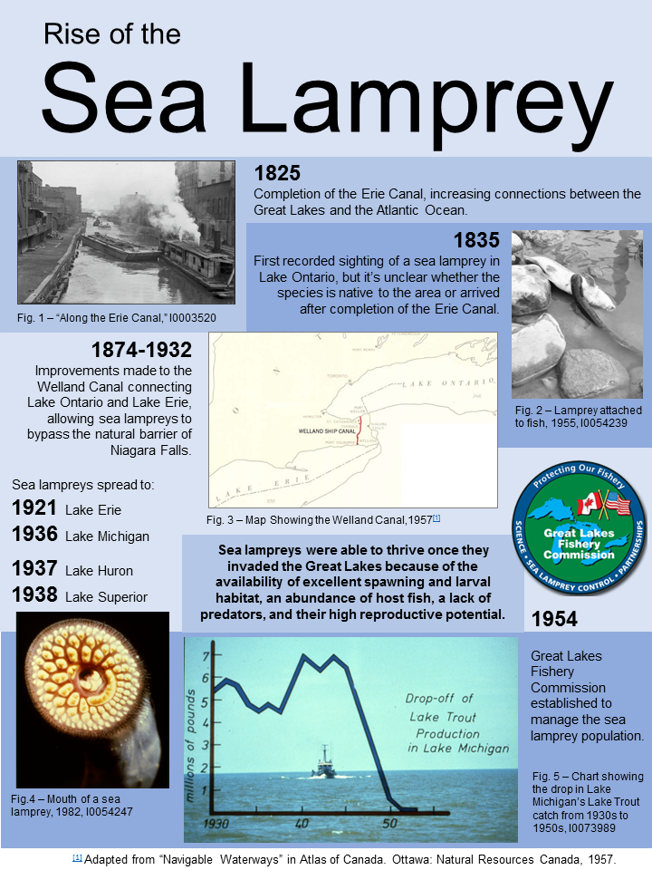

Gathering/Organizing Evidence Worksheet

Source | What kind of action  does this source show or describe? | What are some possible impact(s) of this action on the surrounding ecosystems? | Positive, Negative, or Neutral Impact?
1
2
3
4
5

Primary Source 1

Title: Sea lamprey weir
Date: [195?-196?]
Place: Lake Erie, Ontario
Creator: Ministry of Natural Resources, Fisheries Branch, RG 1-659
Archives of Ontario

Did you know?
A weir is a physical barrier that can stop the movement of fish and other animals up and down a river.
This can be useful as a method of preventing invasive species moving upstream.

Primary Source 2

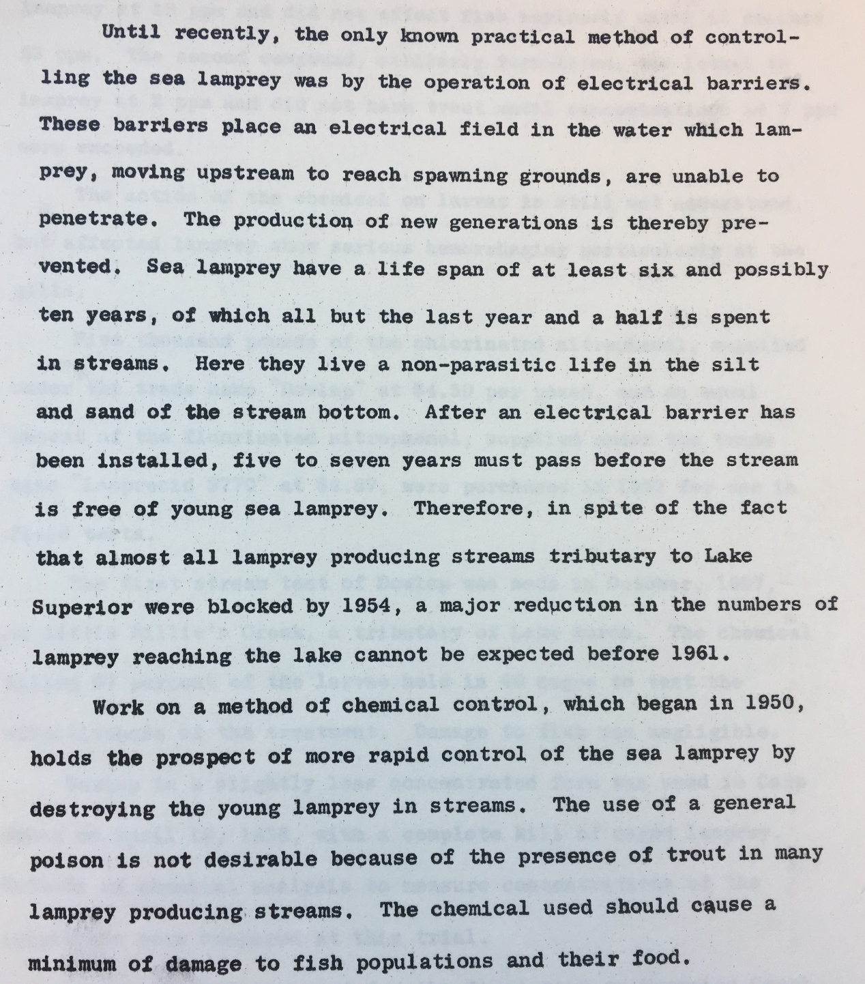

Title: Excerpt from “Sea Lamprey Control with Chemicals” (page 1)
Date: August 25, 1958
Creator: Great Lakes Fishery Commission, RG 1-289-1-39
Archives of Ontario

Primary Source 3

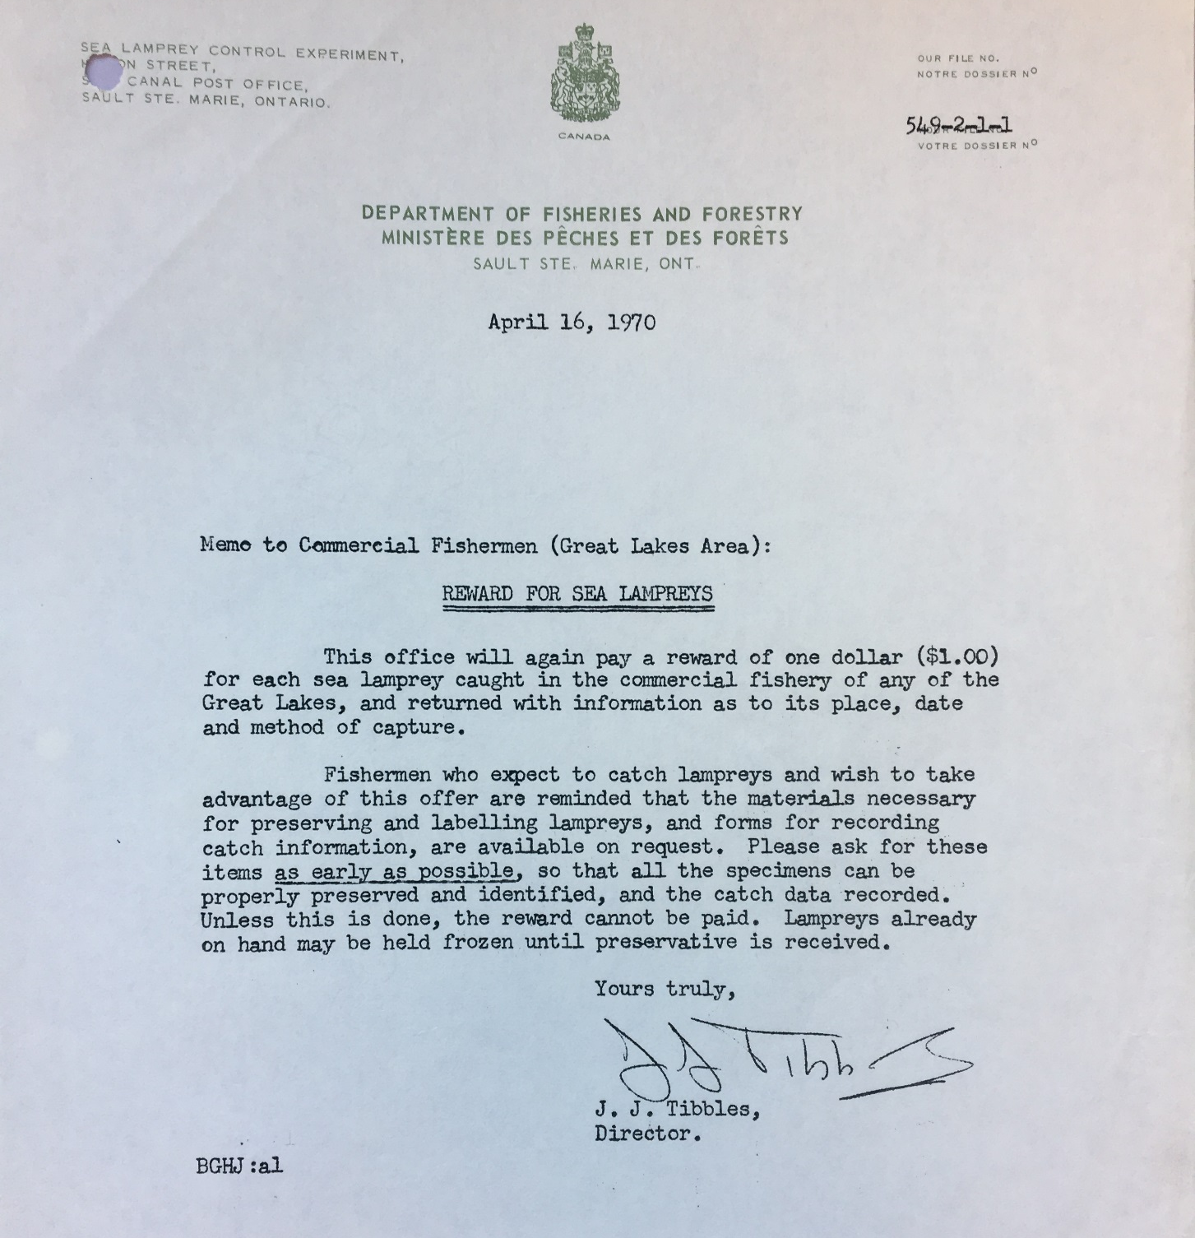
Title: “Note to Commercial Fishermen (Great Lakes Area): REWARD FOR SEA LAMPREYS”
Date: April 16, 1970
Creator: J.J. Tibbles, Director, Sea Lamprey Control Experiment
Collection: Ministry of Natural Resources, Fisheries Branch, RG 1-289-1-39
Archives of Ontario

Primary Source 4

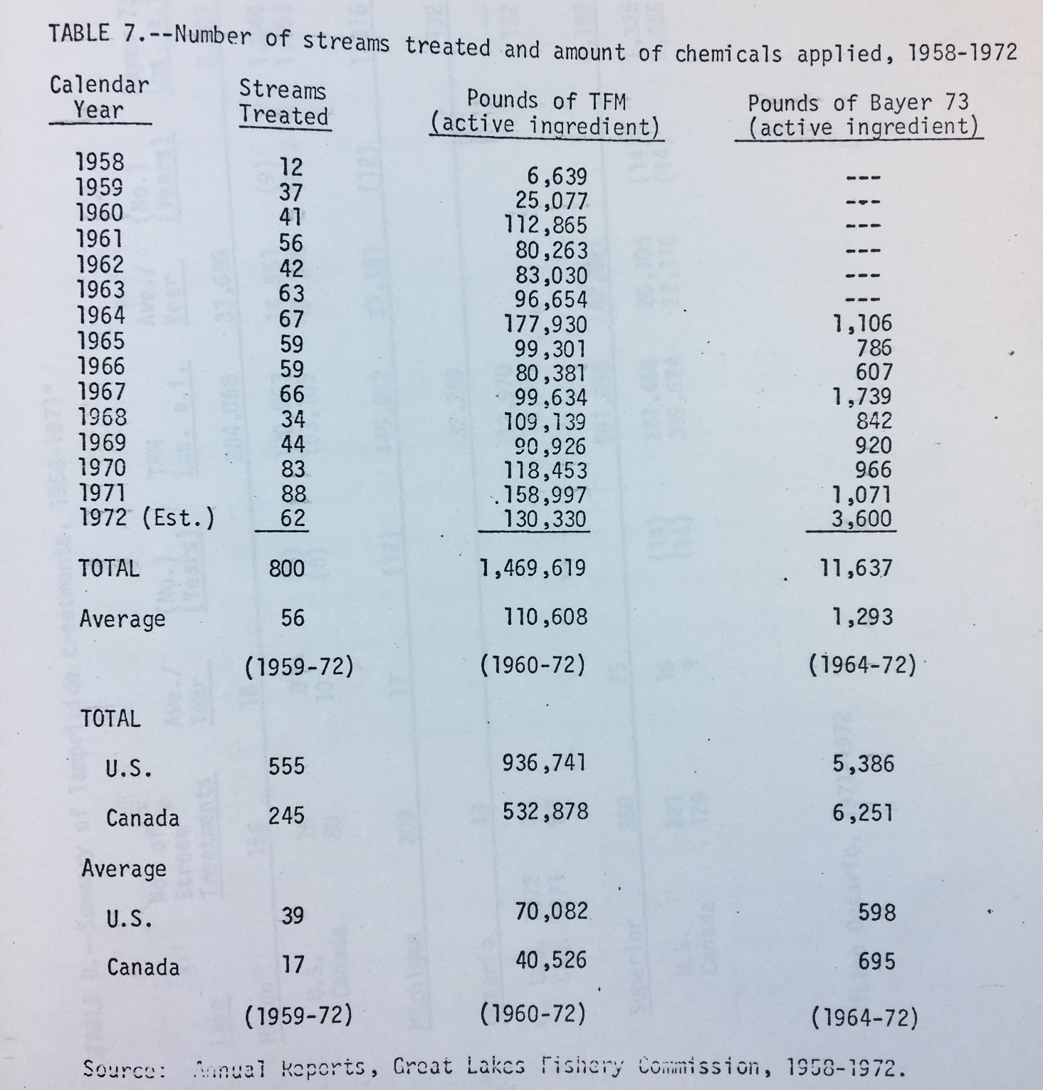

Title: “Table 7. –Number of streams treated and amount of chemicals applied, 1958-1972” from US Department of the Interior Draft Environmental Impact Statement
Date: May 23, 1973
Creator: Great Lakes Sea Lamprey Control Program, Bureau of Sport Fisheries and Wildlife
Collection: Ministry of Natural Resources, Fisheries Branch, RG 1-289-1-388
Archives of Ontario

Primary Source 5

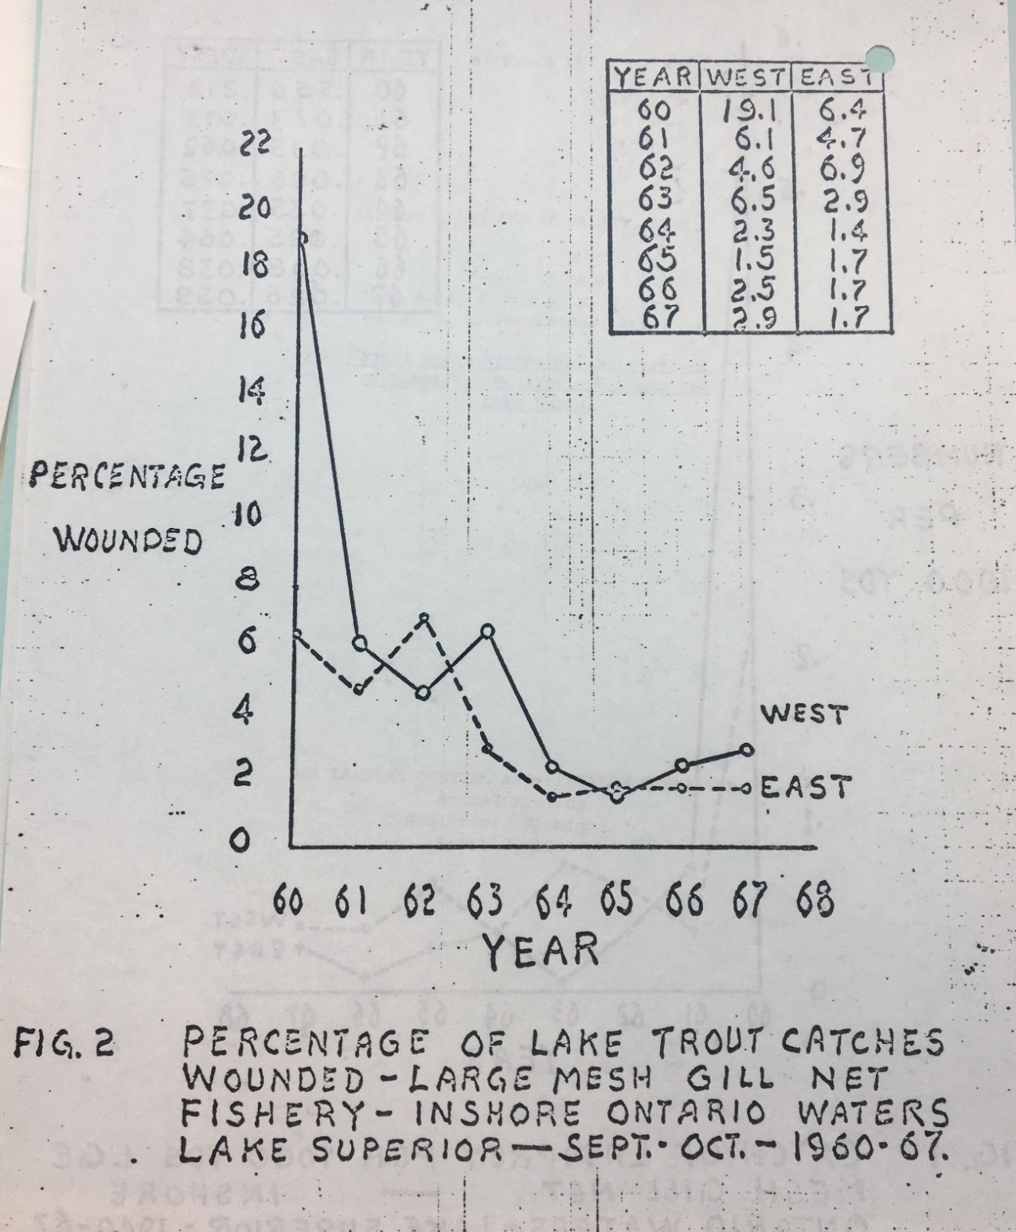
Title: “Fig. 2 Percentage of Lake Trout Catches Wounded – Large Mesh Gill Net Fishery – Inshore Ontario Waters Lake Superior – Sept.-Oct.-1960-67”
Date: 1968
Creator: Great Lakes Fishery Commission, Sea Lamprey Control and Research committee
Collection: Ministry of Natural Resources, Fisheries Branch, RG 1-289-1-258
Archives of Ontario

